OPINION

High School Doesn’t Have to Be Boring
Debate, drama and other extracurriculars provide the excitement many classrooms lack. And they can help overhaul the system.
March 30, 2019
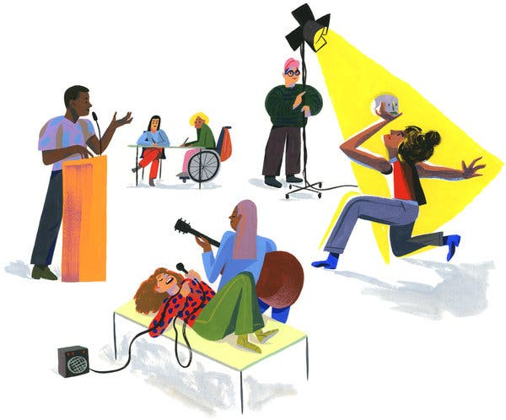

By Jal Mehta and Sarah Fine
The writers spent six years traveling the country studying high schools.
When you ask American teenagers to pick a single word to describe how they feel in school, the most common choice is “bored.” The institutions where they spend many of their waking hours, they’ll tell you, are lacking in rigor, relevance, or both.
They aren’t wrong. Studies of American public schools from 1890 to the present suggest that most classrooms lack intellectual challenge. A 2015 Gallup Poll of nearly a million United States students revealed that while 75 percent of fifth-grade students feel engaged by school, only 32 percent of 11th graders feel similarly.
What would it take to transform high schools into more humanizing and intellectually vital places? The answer is right in front of us, if only we knew where to look.
When the two of us — a sociologist and a former English teacher — began our own investigation of this question several years ago, we made two assumptions. Both turned out to be wrong.
The first was that innovative schools would have the answers. We traveled from coast to coast to visit 30 public high schools that had been recommended by leaders in the field. What we saw, however, was disheartening. Boredom was pervasive. Students filled out worksheets, answered factual questions, constructed formulaic paragraphs, followed algorithms and conducted “experiments” for which the results were already known. Covering content almost always won out over deeper inquiry — the Crusades got a week; the Cold War, two days.
The result? In lower-level courses, students were often largely disengaged; in honors courses, students scrambled for grades at the expense of intellectual curiosity. Across the different class types, when we asked students to explain the purpose of what they were doing, their most common responses were “I dunno” and “I guess it’ll help me in college.”
Our second mistake was that we assumed the place to look for depth was in core academic classes. As we spent more time in schools, however, we noticed that powerful learning was happening most often at the periphery — in electives, clubs and extracurriculars. Intrigued, we turned our attention to these spaces. We followed a theater production. We shadowed a debate team. We observed elective courses in green engineering, gender studies, philosophical literature and more.
As different as these spaces were, we found they shared some essential qualities. Instead of feeling like training grounds or holding pens, they felt like design studios or research laboratories: lively, productive places where teachers and students engaged together in consequential work. It turned out that high schools — all of them, not just the “innovative” ones — already had a model of powerful learning. It just wasn’t where we thought it would be.
Consider the theater production that we observed at a large public high school in an affluent suburban community. Students who had slouched their way through regular classes suddenly became capable, curious and confident. The urgency of the approaching premiere lent the endeavor a sense of momentum. Students were
no longer vessels to be filled with knowledge, but rather people trying to produce something of real value. Coaching replaced “professing” as the dominant mode of teaching. Apprenticeship was the primary mode of learning. Authority rested not with teachers or students but with what the show demanded.
What we saw on a debate team in a high-poverty urban public school was similar. Monthly debate competitions gave the work a clear sense of purpose and urgency. Faculty members and older students mentored the novices. Students told us that “debate is like a family.” Perhaps most important, debate gave students a chance to speak in their own voices on issues that mattered to them. Inducted into an ancient form of verbal and mental discipline, they discovered a source of personal power.
In essence, two different logics reign in the same buildings. Before the final bell, we treat students as passive recipients of knowledge whose interests and identities matter little. After the final bell — in newspaper, debate, theater, athletics and more — we treat students as people who learn by doing, people who can teach as well as learn, and people whose passions and ideas are worth cultivating. It should come as no surprise that when we asked students to reflect on their high school experiences, it was most often experiences like theater and debate that they cited as having influenced them in profound ways.
The truly powerful core classes that we found — and at every school there were some — echoed what we saw in extracurriculars. Rather than touring students through the textbook, teachers invited students to participate in the authentic work of the field. For example, a skillful science teacher in a high-poverty-district high school offered a course in which her students designed, researched, carried out and wrote up original experiments. While the experiments varied in their sophistication, all students were initiated into what it meant to do science. In turn, this allowed them to understand that science is a messy and uncertain business — much less knowable than it seems when reciting Newton’s laws.
Why are classrooms like that one so rare? It’s not the teachers’ fault. The default mode of the classrooms we observed reflects the mold in which public high schools were cast a century ago. Students are batch-processed, sorted into tracks based on perceived ability and awarded credits based on seat time rather than actual learning. Making matters worse are college admissions pressures, state testing, curriculum frameworks that emphasize breadth over depth, simplistic systems of teacher evaluation, large classes, large teacher loads and short class periods. The result is that it often feels as though teachers and students have been conscripted into a game that nobody wants to be playing.
How can we make what happens before the bell more like what happens after it?
Schools need to become much more deeply attached to the world beyond their walls. Extracurriculars gain much of their power from their connections to their associated professional domains. School subjects, in comparison, feel devoid of context. Promising schools tackle this dilemma in different ways: Some use project-based learning to engage students in their local communities; some collaborate with museums, employers and others who can give students experiences in professional domains; still others prioritize hiring teachers who have had experience working in (and not just teaching about) their fields. All of these choices bring meaning to work that is too often taught in a vacuum.
Teachers need both more freedom and more support. They need longer class periods, opportunities for collaboration and teaching loads small enough to allow them to form real relationships with students. They need expectations for topic coverage that permit more opportunities for depth. They need districts that focus less on compliance and more on helping teachers learn in rich ways that parallel how those teachers might teach their students. Finally, teachers need parents who ask, “What is my child curious about?” rather than “How did she do on the test?”
Most important of all, high school students need to be granted much more agency, responsibility and choice. While there are some things that everyone should know, much of what will help students in college and beyond are skills: the ability to speak and write persuasively, to reason and engage with one another’s reasoning and to think about core content in complicated ways. Happily, there are multiple paths to achieving these ends. Students can choose what scientific puzzles to explore and what English or history electives to take while still developing a shared foundation of skills.
More radically, what was powerful about extracurriculars is that students were supported in leading their learning. They were taking responsibility for teaching others and gradually becoming the ones who upheld the standards of the field. The more we can create similar opportunities in core subjects — giving students the freedom to define authentic and purposeful goals for their learning, creating opportunities for students to lead that learning, and helping them to refine their work until it meets high standards of quality — the deeper their learning and engagement will be.
The pervasiveness of the disengagement that we witnessed suggests a need to radically remake the American high school. At the same time, the pockets of powerful learning we observed demonstrate what is possible. Perhaps the first step involves what one school leader told us. “Most schools and classrooms are set up in ways that trigger adolescents to resist,” he said. “What we need to do is to trigger their instinct to contribute.”

Jal Mehta (@jal_mehta) is an associate professor at the Harvard Graduate School of Education. Sarah Fine (@sarahmfine) runs a teacher preparation program at the High Tech High Graduate School of Education in San Diego. They are the authors of “In Search of Deeper Learning: The Quest to Remake the American High School.”
The Times is committed to publishing a diversity of letters to the editor. We’d like to hear what you think about this or any of our articles. Here are some tips. And here’s our email: letters@nytimes.com.
Follow The New York Times Opinion section on Facebook, Twitter (@NYTopinion) and Instagram.

