Plot Structure Name____________________
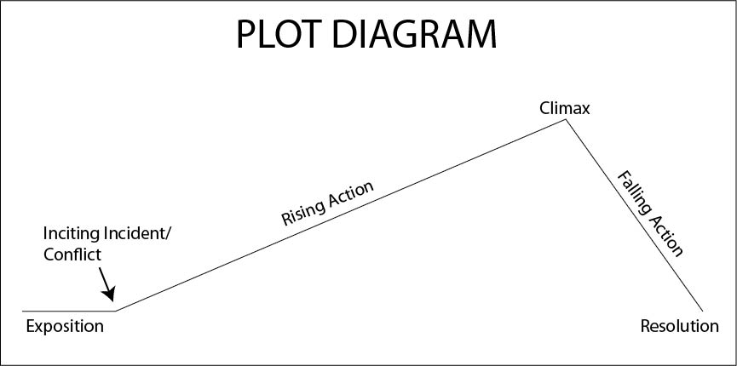
The EXPOSITION
- This is usually the beginning of the story.
- Characters are introduced
- Setting is described, relevant background information is given.
The CONFLICT
- The main problem (conflict) in the story is introduced. This problem forms the basis for the major action in the rest of the story.
The RISING ACTION
- This section usually makes up most of the story.
- In the rising action, the conflict is complicated and tension and suspense are built.
- This draws readers in so they are more interested in learning how the conflict will be resolved.
The CLIMAX
- This is the turning point in the story at which readers learn what the outcome of the conflict will be. It is USUALLY (but not always) the point of highest excitement in the story.
The FALLING ACTION
- This is the part of the story that follows the climax.
- At this point, the conflict is resolved; any events that occur immediately after the climax are included in the falling action.
The RESOLUTION or DENOUEMENT
- In the resolution, any loose ends in the story are tied up.
- It doesn’t necessarily mean “happily ever after;” not everything needs to be resolved.
- There should be a sense of finality and inevitability to the resolution.
- The author may draw attention to themes in the novel in the resolution.
Fill out the chart below for the story you read. Describe what happens in each part of the plot in your story.
4. Climax:

6. Resolution:

3. Rising Action:

5. Falling Action:

2. Conflict:

- Exposition:

